CHILDCARE OPTIONS
AND REIMBURSEMENT

We encourage everyone who calls Coastal Life Church home to join a Group. Why? Because we believe that Groups are the best environment for you to connect relationally and grow spiritually. We understand that there are seasons of life when the cost of necessary childcare can become the singular deterrent to participation in a Group. We are committed to removing as many obstacles to spiritual growth as possible. Below are the instructions for requesting childcare benevolent support.

We have three options for childcare while the Group meets:
- Group members could bring children to the Group meeting location and have a separate room for them to be in while the Group meets. Children would play on their own while the Group meets. (Works best for older children)

- Group members could bring the children to the Group meeting location and hire a childcare provider to care for them while the Group meets.

- Group members could hire a childcare provider to care for their children in their own home.

Benevolent support is available for those Group members where the cost of childcare could present a challenge for them participating in a Group. The general process for requesting childcare reimbursement is described below.

- Group member request the Childcare reimbursement form from their Group Leader or downloads it from our church website. (coastallifechurch.com/groups)
- The Group member completes the form and calculates the total amount for reimbursement based on the Childcare Reimbursement Rate table below.
- Completed Childcare Reimbursement forms must be signed by the Group member and saved in a PDF format. Forms are electronically submitted to: amys@coastallifechurch.com
- Reimbursement forms should be submitted once a month.

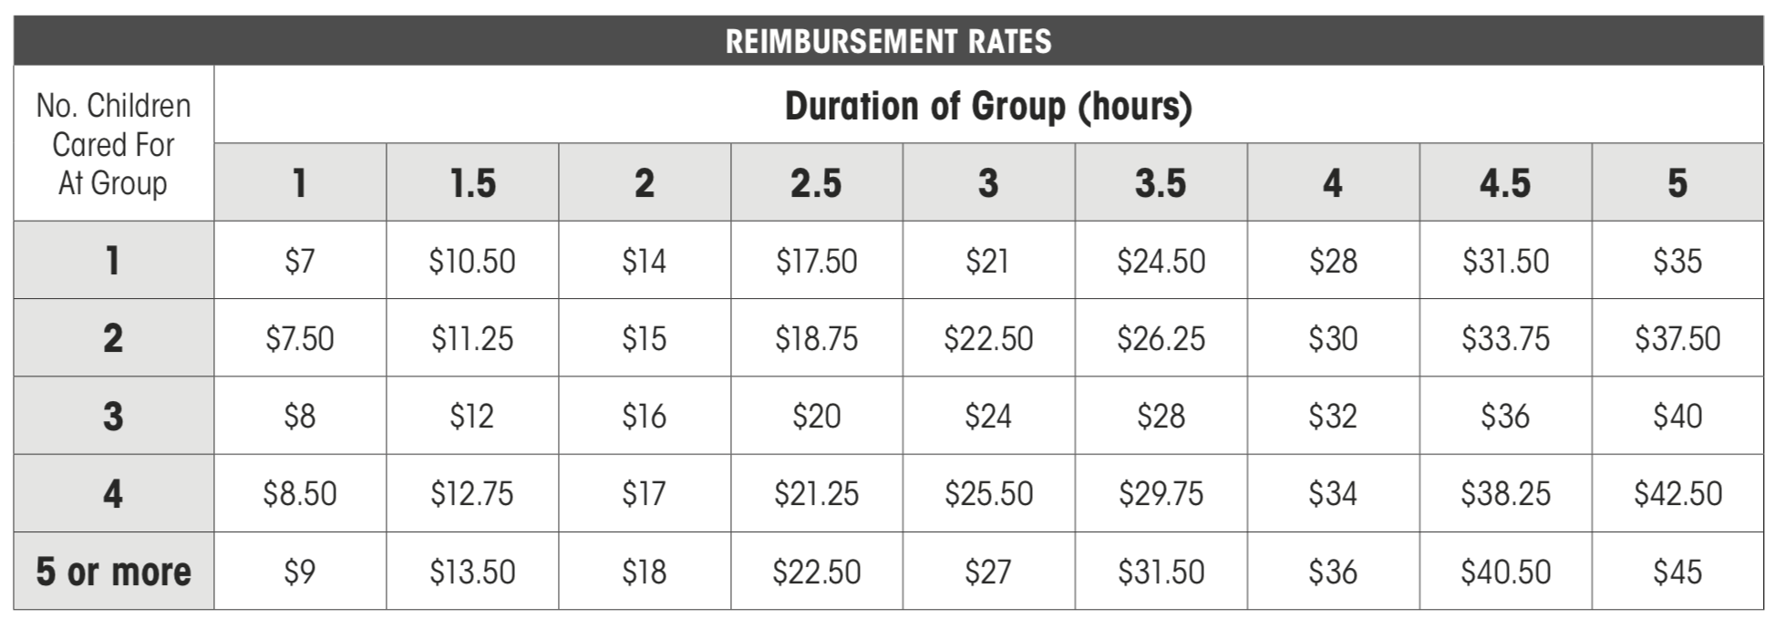

Monthly Payment Request
Childcare Reimbursement for Life Group Participation

PAYABLE TO:

Name _____________________________________________________________________________

Street _____________________________________________________________________________

City, State, Zip _____________________________________________________________________________

Phone _____________________________________________________________________________

Email _____________________________________________________________________________

Life Group Leader Name ____________________________________________________________________

“This reimbursement is requested so that I/we can participate in our Coastal Life Church Group without incurring financial hardship.”

_________________________________________________________________________
Signature
We encourage everyone who calls Coastal Life Church home to join a Life Group. We believe that Life Groups are the best environment for people to connect relationally and grow spiritually. However, we understand that there are seasons of life when the cost of necessary childcare can become the singular deterrent to participation in a Group. We are committed to removing as many obstacles to spiritual growth as possible. If you are part of CLC and have been unable to participate in a Life Group specifically due to the cost of childcare, you may use this form to request a benevolence reimbursement at a predetermined rate for childcare expenses incurred while at your Group.

Please email this form as a PDF to – amys@coastallifechurch.com - within 30 days of the first date of childcare

